FOUNDATION BIOLOGY EXAM QUESTIONS

The diagram below shows a single-celled alga which lives in fresh water.

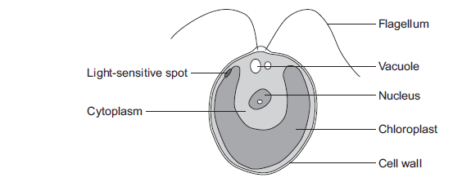

(a) Which part of the cell labelled above:

(i) traps light for photosynthesis

...............................................................................................................

(1)

(ii) is made of cellulose?

...............................................................................................................

(1)

(b) In the freshwater environment water enters the algal cell.

(i) What is the name of the process by which water moves into cells?

...............................................................................................................

(1)

(ii) Give the reason why the algal cell does not burst.

...............................................................................................................

...............................................................................................................

(1)

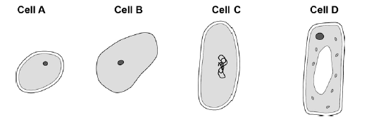
HIGHER BIOLOGY EXAM QUESTIONS

The figure below shows four different types of cell.

(a) Which cell is a plant cell?

Give one reason for your answer.

Cell ..................

Reason ..........................................................................................................

(2)

(b) Which cell is an animal cell?

Give one reason for your answer.

Cell ..................

Reason ..........................................................................................................

(2)

(c) Which cell is a prokaryotic cell?

Give one reason for your answer.

Cell ..................

Reason ..........................................................................................................

(2)

(d) A scientist observed a cell using an electron microscope.

The size of the image was 25 mm.

The magnification was × 100 000

Calculate the real size of the cell.

Use the equation:

Give your answer in micrometres.

........................................................................................................................

........................................................................................................................

........................................................................................................................

Real size = .................................... micrometres

(3)

(Total 9 marks)

FOUNDATION CHEMISTRY QUESTIONS

(a) Figure 1 shows an atom of element G.

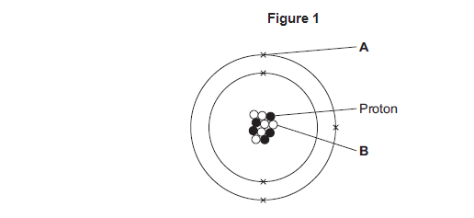

Draw a ring around the correct answer to complete each sentence.

(i) Label A shows

an electron an ion a nucleus

(1)

(ii) The particle labelled B is

an isotope a molecule a neutron

(1)

(iii) The mass number of element G is

5 6 11

(1)

(iv) Use the periodic table to identify element G.

Element G is

boron carbon sodium

(1)

(b) Figure 2 shows a compound of G and hydrogen.

Figure 2

Draw a ring around the correct answer to complete each sentence.

(i) The formula of the compound in Figure 2 is

GH₃ G₃H 3HG

(1)

(ii) The type of bonding shown in Figure 2 is

covalent ionic metallic

(1)

HIGHER CHEM EXAM QUESTIONS

Use the periodic table and the information in the table below to help you to answer the questions.

The table shows part of an early version of the periodic table.

 | Group 1 | Group 2 | Group 3 | Group 4 | Group 5 | Group 6 | Group 7
 | H
 | Li | Be | B | C | N | O | F
 | Na | Mg | Al | Si | P | S | Cl

(a) Hydrogen was placed at the top of Group 1 in the early version of the periodic table.

The modern periodic table does not show hydrogen in Group 1.

(i) State one similarity between hydrogen and the elements in Group 1.

...............................................................................................................

...............................................................................................................

(1)

(ii) State one difference between hydrogen and the elements in Group 1.

...............................................................................................................

...............................................................................................................

(1)

(b) Fluorine, chlorine, bromine and iodine are in Group 7, the halogens.

The reactivity of the halogens decreases down the group.

Bromine reacts with a solution of potassium iodide to produce iodine.

Br₂ + 2KI 2KBr + I₂

(i) In the reaction between bromine and potassium iodide, there is a reduction of bromine to bromide ions.

In terms of electrons, what is meant by reduction?

...............................................................................................................

...............................................................................................................

(1)

FOUNDATION EXAM PHYS

When you transfer energy to a shopping trolley, the amount of work done depends on the force used and the distance moved.

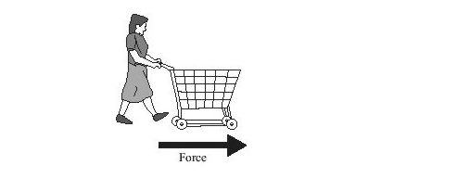

Complete the table by using the correct units from the box.

joule (J) metre (m) newton (N)

The first one has been done for you.

Quantity | Unit
energy (transferred) | joule
force
distance (moved)
work done

(Total 2 marks)

HIGHER PHYS EXAM QUESTIONSThe figure below shows a rollercoaster.

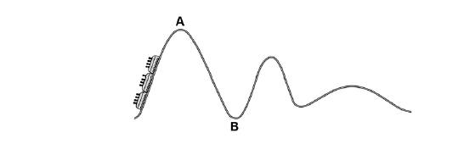

The rollercoaster car is raised a vertical distance of 35 m to point A by a motor in 45 seconds.

The mass of the rollercoaster is 600 kg.

The motor has a power rating of 8 000 W.

(a) Calculate the percentage efficiency of the motor.

Gravitational field strength = 9.8 N / kg.

........................................................................................................................

........................................................................................................................

........................................................................................................................

........................................................................................................................

........................................................................................................................

........................................................................................................................

Efficiency = ................................... %

(5)

(b) The rollercoaster rolls from point A to point B, a drop of 35 m.

Calculate the speed of the roller coaster at point B.

Assume that the decrease in potential energy store is equal to the increase in kinetic energy store.

........................................................................................................................

........................................................................................................................

........................................................................................................................

........................................................................................................................

........................................................................................................................

........................................................................................................................

Speed at point B = ................................... m / s

(6)

